 | 26.9.5 Editors - Properties Editor - Modifiers Properties Tab - Curve&Text - Modify modifiers
Table of content
Detailed table of content 1
Curve&Text - Modify modifiers 2
Mesh Cache 2
Mesh Sequence Cache 3

Detailed table of content
Detailed table of content
Detailed table of content 1
Curve&Text - Modify modifiers 2
Mesh Cache 2
Format 2
File Path 2
Influence 2
Deform Mode 2
Interpolation 2
Time Remapping 3
Frame / Time / Factor 3
Play Mode 3
Frame Start 3
Frame Scale 3
Axis Mapping 3
Forward/Up Axis 3
Flip Axis 3
Mesh Sequence Cache 3
Data property 3
Data browser 3
Name 4
Fake User 4
Open Cache File 4
Remove 4
File Path 4
Load File 4
Refresh Active 4
Sequence 4
Use Render Engine Procedural 4
Use Prefetch 4
Prefetch Cache Size 4
Override Frame 4
Frame 4
Frame Offset 5
Velocity Attribute 5
Velocity Unit 5
Frame 5
Second 5
Object Path 5
Velocity Scale 5

Curve&Text - Modify modifiers

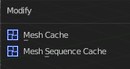

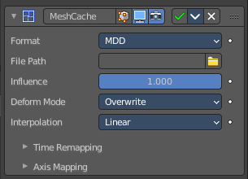
Mesh Cache
The Mesh Cache modifier allows you to apply animated mesh data to a mesh. And deform it when playing back.
This works in a similar way to shape keys. But uses external files, and allows to interchange between applications.
Tip! Both MDD and PC2 depend on the vertex order on the mesh remaining unchanged. This is a limitation of this method, so take care not to add/remove/reorder vertices once this modifier is used.

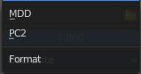
Format
The input file format (currently .mdd and .pc2 are supported).

File Path
Path to the cache file.

Influence
Factor to adjust the influence of the modifier’s deformation.

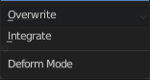
Deform Mode
This setting defaults to Overwrite which will replace the vertex locations with those in the cache file.
When you want to mix a mesh cache file with shape keys, then you can select the Deform option which integrates deformations with the mesh cache result.
Note that this feature is limited to making smaller, isolated edits and will not work for larger changes such as re-posing limbs.

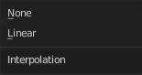
Interpolation
The blend mode between frames. Use linear when the frames in the cache file do not match up exactly with the frames in the blend-file.

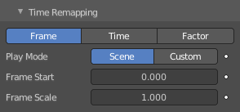
Time Remapping

Frame / Time / Factor
How time is calculated.

Play Mode
How playback operates.

Frame Start
Play the cache starting from this frame.

Frame Scale
Scale time by this factor (applied after the start value).

Axis Mapping

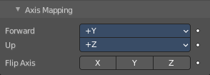
Forward/Up Axis
The axis for forward and up used in the source file.

Flip Axis
Allows you to flip the coordinates on an axis.

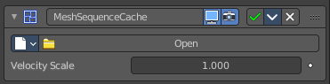
Mesh Sequence Cache
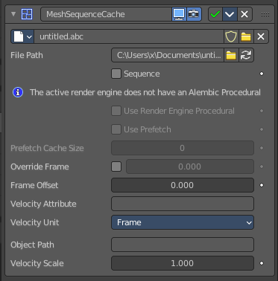
The Mesh Sequence Cache modifier loads data from Alembic files. It supports static meshes, but is mostly used to load animated meshes. Despite its name, this modifier also supports curves. It also handles file sequences, as well as meshes and curves with varying topology (like the result of fluid simulations).
The mesh version of this modifier looks a bit different.
When importing an Alembic file, Mesh Sequence Cache modifiers are automatically added to time-varying meshes. For time-varying object transforms (so animation of rotation, location, or scale), the Transform Cache Constraint is used.
The

Data property

Data browser
List of available Alembic files.

Name
The name of the current active alembic file.

Fake User
Keep this file in the scene even when it has no user anymore.

Open Cache File
Open an alembic file.

Remove
Remove the alembic file.

File Path
Path to the Alembic file.

Load File
Open an alembic file.

Refresh Active
Update the files and paths.

Sequence
Whether or not the cache is separated in a series of files.

Use Render Engine Procedural
This feature is just available for Cycles, and just in an experimental state.
Display boxes as placeholders in the viewport.

Use Prefetch
This feature is just available for Cycles, and just in an experimental state.
When enabled, the Cycles procedural will preload animation data for faster update.

Prefetch Cache Size
This feature is just available for Cycles, and just in an experimental state.
Memory usage limit for the cache. If the data size does not fit the renderer is aborted. 0 disables the feature.

Override Frame
Whether to use a custom frame for looking up data in the cache file, instead of using the current scene frame.

Frame
The time to use for looking up the data in the cache file, or to determine which to use in a file sequence.

Frame Offset
Define a frame offset to the current frame.

Velocity Attribute
Name of the Alembic Attribute used for generating motion blur data.

Velocity Unit
Define how velocity vectors are interpreted regarding time.

Frame
The delta time is 1 frame.

Second
The delta time is 1/FPS.

Object Path
The path to the Alembic object inside the archive.

Velocity Scale
Multiplier used to control the magnitude of the velocity for time effects.

